**Determination of soluble silicate in water by Seal AutoAnalyzer (AA3)**

The AutoAnalyzer is an automated analyzer using a flow technique called continuous flow analysis (CFA). CFA is a continuous stream of reagents divided by air bubbles into discrete segments in which chemical reactions occur. The functions of the bubbles are reducing dispersion and inter-sample carryover, cleaning the tubing and mixing within each segment.

CFA system consists of an autosampler, a peristaltic pump, a chemistry manifold (tubes and coils), a detector (photometer) and data acquisition software:

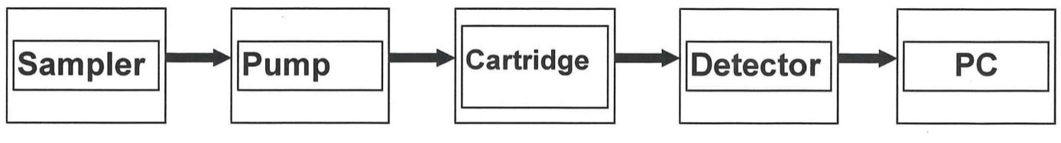

This automated wet-chemistry measurement relies on the fact that the intensity of colored silica compound and its light absorbance is proportional to sample concentration. The output of the system is peaks with heights compared with that of standards measured under the same conditions.

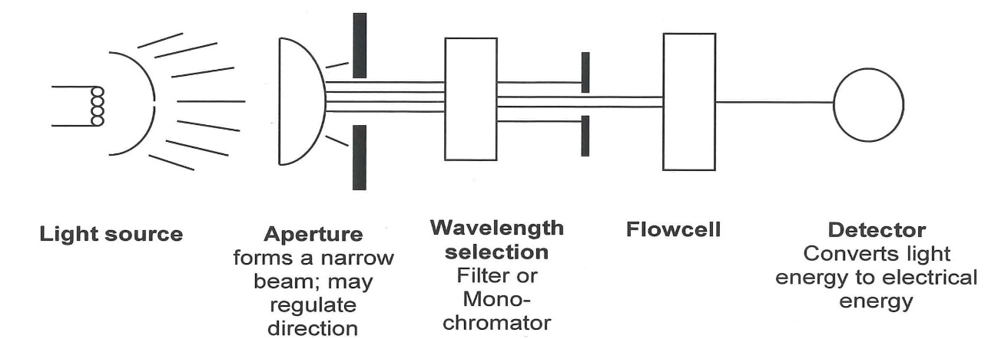

Construction of the photometer.

The procedure is based on the reduction of Molybdate in acidic solution to “molybdenum blue” by ascorbic acid. Introducing of oxlalic acid to sample stream before the addition of ascorbic acid is to minimize interferences from phosphates. The measurement is made at 660nm, the wavelength of maximum absorption.

References:

Method No. G-147-95 Rev. 4 (multitest MT7/8), AutoAnalyzer applications, Seal-analytical.

Methods for the analysis of Inorganic substances in water and fluvial sediments, U.S. Geological Survay, (1-2700-78), p. 821-825.

